**A**

**REPORT ON**

**Pneumatic Sheet Metal Shearing Machine**

Submitted by

**Mr. Pratik Gautam Jadhav**

Under the Valuable Guidance of

**Mr. R.R.Gaji**

(Designation- Assistant Professor)



**DEPARTMENT OF MECHANICAL ENGINEERING**

**ANNASAHEB DANGE COLLEGE OF ENGINEERING AND TECHNOLOGY, ASHTA.**

***YEAR: 2017 – 2018***

**ACKNOWLEDGMENT**

I take this opportunity to express my sincere thanks to **Mr. S. S. Ahankari,** Head of Mechanical Engineering Department, Annasaheb Dange college of Engineering and Technology, Ashta for his encouragement to complete this project work successfully.

I would like to express my sincere thanks to **Prof. Mr. R.R.Gaji** (guide) and Prof. S. S. Ahankari (project guide) for his valuable suggestions and guidance to complete this report work

I am thankful to **Dr. A. M. Mulla**, Principal of Annasaheb Dange college of Engineering and Technology, Ashta for extending me all facilities at Annasaheb Dange college of Engineering and Technology, Ashta.

I am very grateful to **Prof. R. A. Kanai, Executive** Director of, Annasaheb Dange college of Engineering and Technology, Ashta for helping me and providing various suitable facilities which are useful to complete this report work.

I am thankful to my parents and friends for kind support.

I am grateful to the staff, Library staff of Annasaheb Dange college of Engineering and Technology, Ashta, and all those who have been instrumental directly or indirectly in the process of completion of this project work.

**Place:** ADCET, Ashta **Mr. Pratik Jadhav**

**Date: T.E. Mech C**

**CONTENTS**

**CHAPTER TITLE PAGE NO**

**Chapter 1 Introduction 4**

**Chapter 2 Shearing Machine 5**

2.1 Types of shearing Machine 5

2.2 Brief description of all the types is as follows **5**

**Chapter 3 History 6**

**Chapter 4 Construction 7**

4.1 Raw Material Used 7

4.2 Ready Items Used 7

## 4.3 Machines & Tools Used 7

**Chapter 5 Working 8**

**Chapter 6 Merits & Demerits 11**

6.1 Merits 11

6.2 Demerits 11

**Chapter 7 Future Scope 12**

**Chapter 8 Conclusion 13**

**Chapter 9 References 14**

**Chapter 1. Introduction**

The formation of any business begins with someone producing the initial idea for the project. The continued success of an established business depends upon the number and quality of the ideas fed into it. Without a continual flow of new ideas, a business cannot function profitably or expand successfully and must, therefore eventually fade into total obscurity.

Ideas for a new business project, a new product, a means of reducing manufacturing costs or for solving industrial labour problems, begin in the human mind. Most people conceive their ideas unconsciously, and because they are unaware of the mental mechanics that caused the ‘idea’ to be produced, they cannot repeat the ideation process to produce further profitable ideas at will.

Fortunately, there are available established creative techniques which, when used correctly, do enable a person to produce a large number of first-class ideas at will. One such creative technique, and probably the most widely used in American industry, is ’brainstorming’.

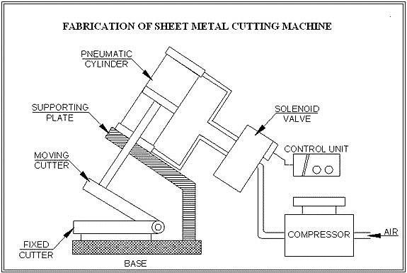

**Fig. 1.1 Concept Image for Project.**

**Chapter 2. Shearing Machine**

In shearing or cutting operation as or blade descends upon the metal, the pressure exerted by the blade first cause the plastic deformation of the metal. Since the clearance between the two blades is very small, the plastic deformation takes place in a localized area and the metal adjacent to the cutting edges of the blade edges becomes highly stressed, which causes the fracture to start on both sides of the sheet as the deformation progresses and the sheet is sheared.

**2.1 Types of shearing Machine:**

* Pneumatically operated
* Hydraulically operated
* Rack and pinion operated
* Spring operated

**2.2 Brief description of all the types is as follows:**

**Pneumatically operated:-**

Here the advancement of the header is carried out in the upward and the downward direction using the pneumatic double acting piston and cylinder unit arrangement along with the foot operated direction control valve. In this type of machine high pressure air is used as the working fluid for the transfer of power and the motion.

**Hydraulically operated:-**

Here the lowering and raising of the header is carried over using the hydraulic piston and cylinder arrangement. To actuate the piston and cylinder, the oil is allowed to enter the cylinder from front or the back side of the piston. But the oil is comparatively costlier and its leakage may cause so many problems.

**Rack and pinion operated:-**

Here the lowering and the raising of the header are carried out manually using the rack and pinion arrangement. In this case the required pressure is applied manually using direct hand pressure on the rack using pinion and lever arrangement. Since the machine is robust and requires large pressure, hence it is not suitable.

**Spring operated:-**

The working of spring operated machine is similar to the rack and pinion operated machine but differs from it in construction. Here the lowering and the raising of the heating handle are carried out manually and it requires too much pressure for its operation and also there is possibility of having damage to the work piece if not handled carefully.

**Chapter 3. History**

Pneumatics, from the Greek (pneumatikos, coming from the wind) is the use of pressurized gases to do work in science and technology. Pneumatics was first documented by Hero of Alexandria in 60 A.D., but the concept had existed before then.

Pneumatic products represent a multi-billion dollar industry today.

Pneumatic devices are used in many industrial applications. Generally appropriate for applications involving less force than hydraulic applications, and typically less expensive than electric applications, most pneumatic devices are designed to use clean dry air as an energy source. The actuator then converts that compressed air into mechanical motion. The type of motion produced depends on the design of the actuator. Pneumatics is employed in a variety of settings.

In dentistry applications, pneumatic drills are lighter, faster and simpler than an electric drill of the same power rating, because the prime mover, the compressor, is separate from the drill and pumped air is capable of rotating the drill bit at extremely high rpm. Pneumatic transfer systems are employed in many industries to move powders and pellets.

Pneumatic devices are also used where electric motors cannot be used for safety reasons, such as mining applications where rock drills are powered by air motors to preclude the need for electric motors deep in the mine where explosive gases may be present.

**Chapter 4. Construction**

## **4.1 Raw Material Used-**

1. Mild Steel bars for base frame.
2. 35C8 material for shearing blades.
3. Cylinder fittings like fork end, base plates, support links.
4. Angle section for blade fitting.
5. Connecting link.
6. Blade link.

**4.2 Ready Items Used-**

1. Pneumatic double acting cylinder.
2. Direction & flow control valves.
3. Pneumatic pipe & pipe fittings.
4. Bolts & nuts.
5. Antirust coat & paint.

## **4.3 Machines & Tools Used-**

1. Cutting Machine.
2. Hacksaw Cutting Machine.
3. Sensitive Drilling Machine.
4. Horizontal Milling Machine.
5. Electric Arc Welding Machine.
6. Table Grinder.
7. Hand Grinder.
8. Surface Grinding Machine.
9. Tap & Tap Holder.

**Chapter 5. Working**

The following figure shows general layout for the machine.

Figure: General Layout

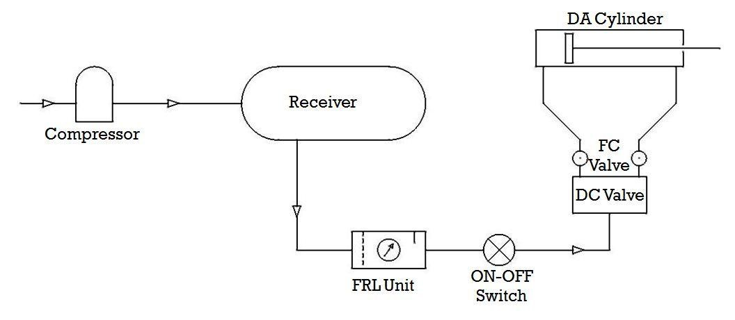

Initially the air-compressor is started and allowed the receiver tank air pressure to reach up to 8 bar. The supply air is then passed to the manifold through FRL unit to condition the air and eligible to industrial use.

From the manifold a separate supply for the machine is taken out and given to ON-OFF switch, so as to operate the machine at will without interrupting the running of compressor.

Then the pipe carries compressed air first to machine’s Direction Control Valve. At position ‘A’ shows the non-actuated circuit diagram. At this position the piston is steady and locked. All ports are in closed condition.

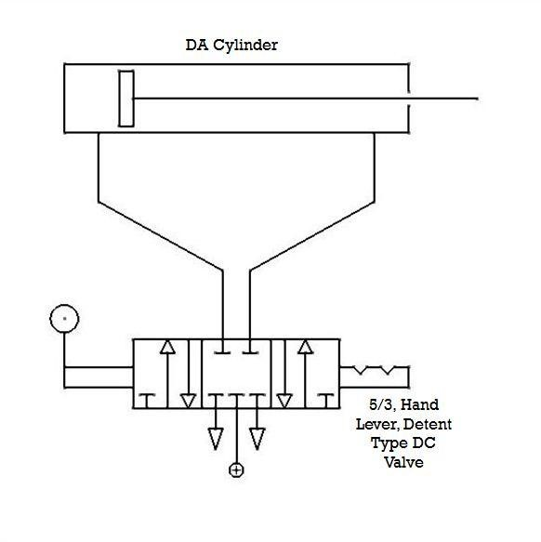

At position ‘B’, the DC valve is at left hand position as shown in figure. The cap end port & pressure port get connected to each other and the rod end port gets connected to the exhaust port. The compressed air comes in the cap end of the cylinder and pushes the pistons outwards. The air already present in the rod end side is pushed out of the cylinder.

When the piston moves outwards, the force is transmitted through the connecting link and the upper blade moves downwards. Before the actuating DC valve the sheet is inserted in between the upper & lower blades. As upper blade moves downwards, the stress is generated in the sheet metal and goes beyond ultimate shear stress of sheet metal. And thus the shearing action takes place.

Now the DC valve is operated to come at position ‘C’, as shown in figure. The rod end port & pressure port get connected to each other and the cap end port gets connected to the exhaust port. The compressed air comes in the rod end of the cylinder and pushes the pistons inwards. The air already present in the cap end side is pushed out of the cylinder.

The sheet metal is either again inserted for further cutting in case of large pieces; the small cut pieces are removed and the next sheet is inserted to cut.

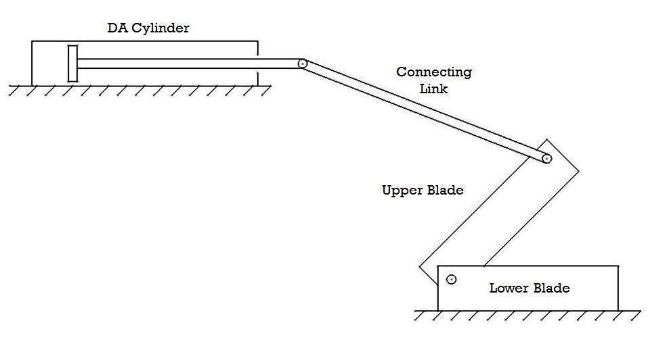

**Chapter 6. Merits & Demerits**

**6.1 Merits-**

* Hydraulics present certain advantages over pneumatics, but in a given application, pneumatic powered equipment is more suitable, particularly in industries where the factory units are plumbed for compressed air.
* Moreover, to avoid corrosive actions, oil or lubricants are added so that friction effects can be reduced.
* Compressed air is used in most of the machines and in some cases compressed carbon dioxide, whereas cutting process is become easy.
* Fast cutting action is carried out.
* Cutting without bending is achieved.

**6.2 Demerits-**

* Sheet more than 2 mm thickness cannot cut easily.
* Compressed air is must.
* Foundation is required also safety major must be taken.

**Chapter 7. Future Scope**

Since old age man is always trying to gain more and more luxurious. Man is always trying to develop more and more modified technique with increasing the aesthetic look and economic consideration. Hence there is always more and more scope. But being the Diploma Engineers and having the ability to think and plan. But due to some time constraints, and also due to lack of funds, we only have thought and put in the report the following future modifications-

* It can be made hydraulically power operated by installing the gear oil pump at the place of air compressor and pneumatic cylinder arrangement.
* It can be made rack and pinion operated or spring and lever operated, by replacing the pneumatic circuit by rack and the pinion arrangement by the square threaded screw and nut arrangement.
* The place where there is scarcity of the electricity the electric motor operate compressor is replaced by an I.C. Engine installed compressor.
* Thus in future there are so many modifications, which we can make to survive the huge global world of competition.

**Chapter 8. Conclusion**

Now we know that Pneumatic Shearing machine is very cheap as compared to hydraulic shearing machine.

The range of the cutting thickness can be increased by arranging a high pressure compressor and installing more hardened blades. This machine is advantageous to small sheet metal cutting industries as they cannot afford the expensive hydraulic shearing machine.

**Chapter 9. References**

* Machine Design by R.S. Khurmi.
* Manufacturing Process by O. P. Khanna and Lal.
* Internet sites-
  + <http://www.google.com/>
  + <http://www.engineersedge.com/>
  + <http://www.efunda.com/>
  + <http://www.mechanicalengineeringblog.com/>